Wazuh Active Response :

Active Response is important because when the attacker tries to do something illegal in the system the server detects it and gives an active response(like if the hacker brute force on your system then the manager block’s the ip).
On Agent side(Windows) , we need to navigate : C:\Program Files (x86)\ossec-agent\ossec.conf
Why: By default, Wazuh agents might reject remote commands for security reasons. You must explicitly allow the agent to accept "Active Response" orders from the Manager.

Verify Agent Permission :
- Open ossec.conf on your Windows machine (as Administrator).
- Search for <active-response>.
- Ensure <disabled> is set to no.
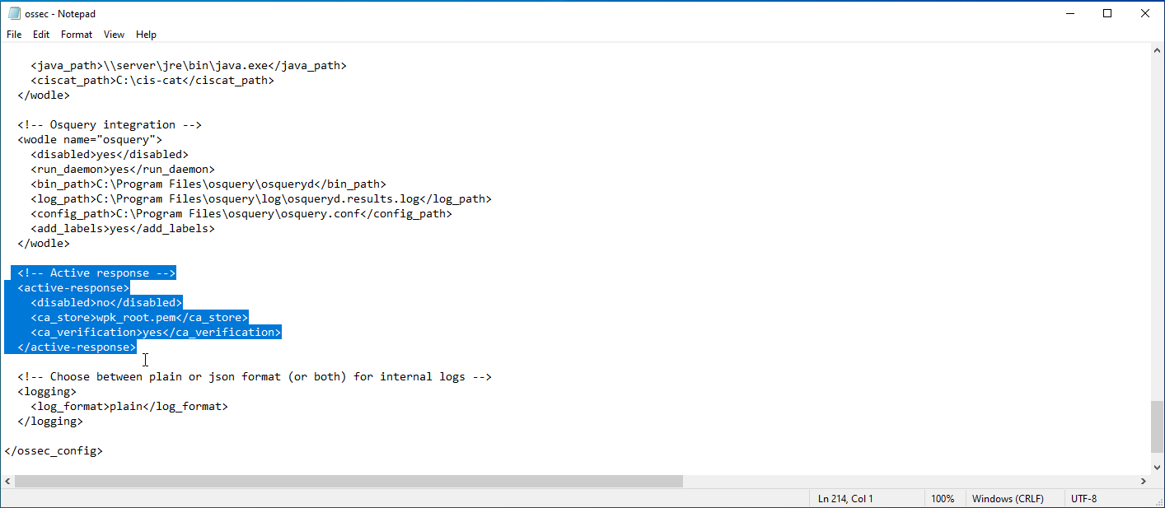

Now, we need to navigate into the wazuh manager side where the server is deployed like mine in Ubuntu. Which directory is : /var/ossec/etc/ossec.conf (On Linux/Ubuntu)

Why: The Agent doesn't know "bad" from "good." The Manager analyzes the logs. You must tell the Manager: "When you see Rule 60122 (Failed Login), tell the specific agent to run the 'route-null' script."

Configure the Trigger :
- Log into your Ubuntu/Linux Manager.
- Open the config file: sudo nano /var/ossec/etc/ossec.conf
- Add this block inside the <ossec_config> tags (usually at the bottom, before the </ossec_config> closing tag).

<command>
<name>win_route-null</name>
<executable>route-null.exe</executable>
<expect>srcip</expect>
<timeout_allowed>yes</timeout_allowed>
</command>

<active-response>
<command>win_route-null</command>
<location>local</location>
<rules_id>60122</rules_id>
<timeout>60</timeout>
</active-response>

Why This command :

Part 1: The Command (Defining the Tool)
This block introduces the tool to the Wazuh Manager. It doesn't do anything yet; it just registers the tool.

- <name>win_route-null</name>: This is the nickname we give the tool. We can call it anything, but win_route-null is standard.
- <executable>route-null.exe</executable>: This is the Real File on the Windows machine. You found this earlier in the bin folder. Without this line, Wazuh doesn't know which file to run.
- <expect>srcip</expect>: This tells Wazuh: "To use this tool, I need a target Source IP Address." (You can't block "nothing").
- <timeout_allowed>yes</timeout_allowed>: This is a safety switch. It allows us to unblock the IP later (so you don't ban yourself forever).

Part 2: The Active Response (The Instruction)
This block tells Wazuh when to use the tool.
- <command>win_route-null</command>: "Use the tool we nicknamed 'win_route-null' above."
- <location>local</location>: Critical! This tells Wazuh to run the script on the specific agent that was attacked. If you put a server, it would try to block the IP on your Ubuntu Manager (which is useless).
- <rules_id>60122</rules_id>: The Trigger. "Only do this if Rule 60122 (Windows Logon Failure) fires."
- <timeout>60</timeout>: The Duration. "Unblock the IP after 60 seconds."

Now it’s time to check if it works or not.

Execute the Attack :
- Go to your Windows Agent.
- Sign out or Lock the screen (Windows Key + L).
- Attempt to log in with a fake user (like a hacker) and a wrong password.
- Repeat this 8 to 10 times as fast as you can. (We need to trigger the threshold).
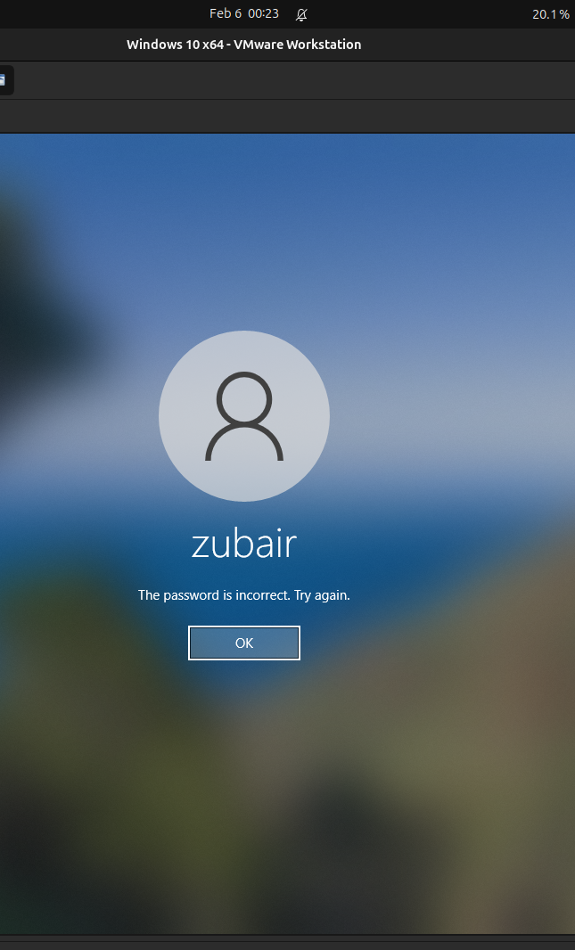

When I try to login as a fake user it’s gives active response and send alert :
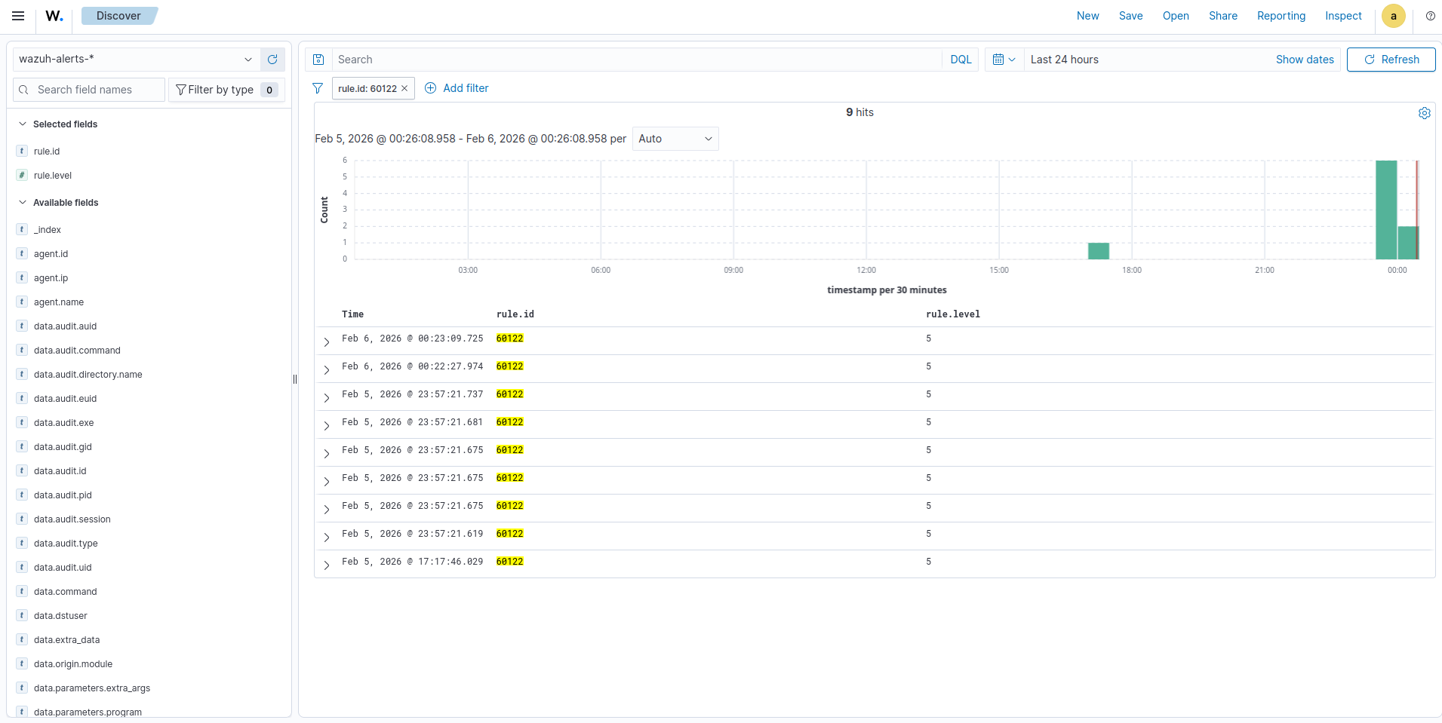

Note : It’s very Important for every Blue Teamer to understand the active response for their professional journey.

